**Object Oriented Programming**

**Teacher: Dr. Tamim Ahmad**

**Assignment # 1**



|  |  |
| --- | --- |
| **Name #** | **Enrollment #** |
| Mudassir Riaz | 01-131232-046 |
| Sami Shahid | 01-131232-066 |

**Department of Software Engineering**

**Bahria University Islamabad Campus**

Timetable Management System

* **Introduction:**

In this assignment, we created a timetable management system, that shows timetable for an individual student from different section/classes, and it also shows timetable for an induvial teacher. Moreover, it shows the timetable for a particular section/class and for a particular room.

* **GitHub link (Mudassir Riaz):**

<https://github.com/mudassirriaz64/OOP-ASSIGNMENT-1/tree/cff57e355084dd25d25d7fc3a4718807554328e3/OOP%20ASSIGNMENT%201>

This repository contains all the .h, .cpp and .txt files with the commits from both the group members. First we created all the program in a single.cpp file after that we divided it into .h and .cpp files with the help of ChatGPT( link to ChatGPT chat is provided at the end of the document )

* **Output Snippets:**

**Following are some snippets from the code output:**

* **Main Menu:**

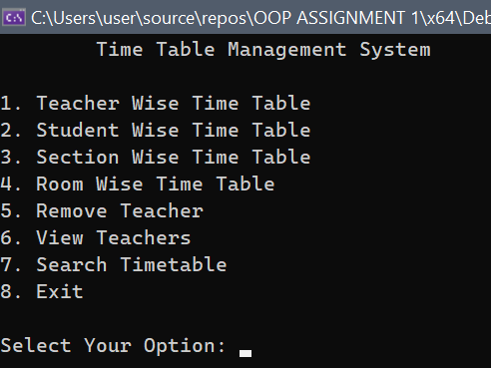

* **Teacher Wise Timetable:**

When you select option 1, the program will ask you for an application id, which is present in teacher.txt file.

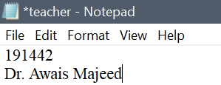

When you enter the application id of the teacher, it prompts the following screen:

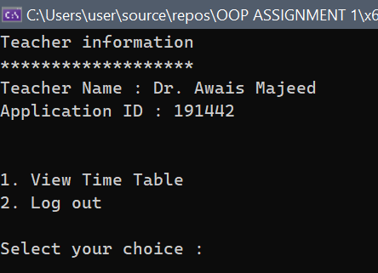

* 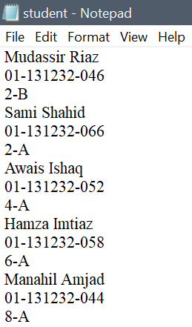**Student Wise Timetable:**

Just like the teacher file, the student wise timetable option will also ask you for the enrollment id of the student, which is present in student.txt, it matches the inputted enrollment id with the enrollment id stored in student.txt:

After inputting the enrollment id , it shows a panel of student like this:

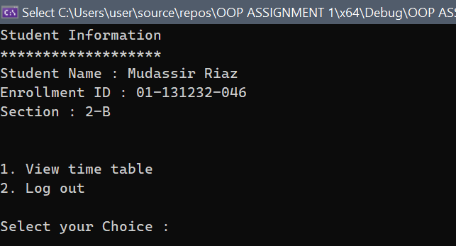

From here, you can view the timetable as an individual student.

* **Section wise Timetable:**



For any section, that is mentioned the program will show the timetable.

* **Room wise Timetable:**

Moreover, you can view teachers, remove teachers, and search timetable for any specific day or time.

* **Conclusion:**

In conclusion, it was a challenging assignment for us to complete, due to that we couldn’t implement all the functionalities that were described in the assignment file, but we did our best to implement as much as we can. One more thing, **YES,** we did take help from ai tools, like ChatGPT, but we understood the code and then implemented the code from ChatGPT in our main function. We have shared the ChatGPT chat history.

* **ChatGPT chat link:**

**https://chat.openai.com/share/8a91df52-1c85-47b0-9508-91335e10b913**  
We took some more help from ChatGPT too like fixing errors in the program, asking for some functionality ideas 😊.